Lab - Configure CDP and LLDP (Instructor Version)

**Instructor Note**: Red font color or gray highlights indicate text that appears in the instructor copy only.

1. Topology

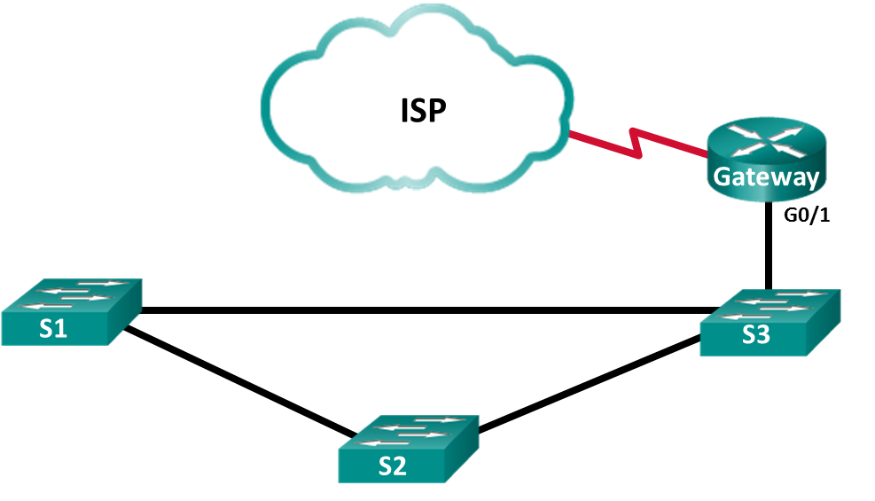

1. Addressing Table

|  |  |  |  |
| --- | --- | --- | --- |
| Device | Interface | IP Address | Subnet Mask |
| Gateway | G0/1 | 192.168.1.254 | 255.255.255.0 |
| S0/0/1 | 209.165.200.226 | 255.255.255.252 |
| ISP | S0/0/1 (DCE) | 209.165.200.225 | 255.255.255.252 |

1. Objectives

Part 1: Build the Network and Configure Basic Device Settings

Part 2: Network Discovery with CDP

Part 3: Network Discovery with LLDP

1. Background / Scenario

Cisco Discovery Protocol (CDP) is a Cisco proprietary protocol for network discovery on the data link layer. It can share information such as device names and IOS versions, with other physically connected Cisco devices. Link Layer Discovery Protocol (LLDP) is vendor-neutral protocol using on the data link layer for network discovery. It is mainly used with network devices in the local area network (LAN). The network devices advertise information, such as their identities and capabilities to their neighbors.

In this lab, you must document the ports that are connected to other switches using CDP and LLDP. You will document your findings in a network topology diagram. You will also enable or disable these discovery protocols as necessary.

**Note**: The routers used with CCNA hands-on labs are Cisco 1941 Integrated Services Routers (ISRs) with Cisco IOS Release 15.2(4)M3 (universalk9 image). The switches used are Cisco Catalyst 2960s with Cisco IOS Release 15.0(2) (lanbasek9 image). Other routers, switches, and Cisco IOS versions can be used. Depending on the model and Cisco IOS version, the commands available and the output produced might vary from what is shown in the labs. Refer to the Router Interface Summary Table at the end of this lab for the correct interface identifiers.

**Note**: Make sure that the routers and switches have been erased and have no startup configurations. If you are unsure, contact your instructor.

**Instructor Note**: Refer to the Instructor Lab Manual for the procedures to initialize and reload devices.

1. Required Resources

* 2 Routers (Cisco 1941 with Cisco IOS Release 15.2(4)M3 universal image or comparable)
* 3 Switches (Cisco 2960 with Cisco IOS Release 15.0(2) lanbasek9 image or comparable)
* Console cables to configure the Cisco IOS devices via the console ports
* Ethernet cables as shown in the topology

1. Build the Network and Configure Basic Device Settings

In Part 1, you will set up the network topology and configure basic settings on the router and switches.

* 1. Cable the network as shown in the topology.

The Ethernet ports used on the switches are not specified in the topology. You may choose to use any Ethernet ports to cable the switches as shown in the topology diagram.

* 1. Initialize and reload the network devices as necessary.
  2. Configure basic device settings for the switches.
     1. Console into the device and enable privileged EXEC mode.
     2. Enter configuration mode.
     3. Disable DNS lookup to prevent the switch from attempting to translate incorrectly entered commands as though they were host names.
     4. Configure the hostname according to the topology.
     5. Verify that the switchports with connected Ethernet cables are enabled.
     6. Save the running configuration to the startup configuration file.
  3. Configure basic device settings for the routers.
     1. Console into the device and enable privileged EXEC mode.
     2. Enter configuration mode.
     3. Copy and paste the following configurations into the routers.

**ISP:**

hostname ISP

no ip domain lookup

interface Serial0/0/1

ip address 209.165.200.225 255.255.255.252

no shutdown

**Gateway:**

hostname Gateway

no ip domain lookup

interface GigabitEthernet0/1

ip address 192.168.1.254 255.255.255.0

ip nat inside

no shutdown

interface Serial0/0/1

ip address 209.165.200.226 255.255.255.252

ip nat outside

no shutdown

ip nat inside source list 1 interface Serial0/0/1 overload

access-list 1 permit 192.168.1.0 0.0.0.255

* + 1. Save the running configuration to the startup configuration file.

1. Network Discovery with CDP

On Cisco devices, CDP is enabled by default. You will use CDP to discover the ports that are currently connected.

* + 1. On router Gateway, enter the **show cdp** command in the privileged EXEC mode to verify that CDP is currently enabled on router Gateway.

Gateway# **show cdp**

Global CDP information:

Sending CDP packets every 60 seconds

Sending a holdtime value of 180 seconds

Sending CDPv2 advertisements is enabled

How often are CDP packets sent?

____________________________________________________________________________________

CDP packets are sent out every 60 seconds.

If CDP is disabled on Gateway, enable CDP by issuing the **cdp run** command in the global configuration mode.

Gateway(config)# **cdp run**

Gateway(config)# **end**

* + 1. Issue the **show cdp interface** to list the interfaces that are participating in CDP advertisements.

Gateway# **show cdp interface**

Embedded-Service-Engine0/0 is administratively down, line protocol is down

Encapsulation ARPA

Sending CDP packets every 60 seconds

Holdtime is 180 seconds

GigabitEthernet0/0 is administratively down, line protocol is down

Encapsulation ARPA

Sending CDP packets every 60 seconds

Holdtime is 180 seconds

GigabitEthernet0/1 is up, line protocol is up

Encapsulation ARPA

Sending CDP packets every 60 seconds

Holdtime is 180 seconds

Serial0/0/0 is administratively down, line protocol is down

Encapsulation HDLC

Sending CDP packets every 60 seconds

Holdtime is 180 seconds

Serial0/0/1 is up, line protocol is up

Encapsulation HDLC

Sending CDP packets every 60 seconds

Holdtime is 180 seconds

cdp enabled interfaces : 5

interfaces up : 2

interfaces down : 3

Vlan1 is administratively down, line protocol is down

Sending CDP packets every 60 seconds

Holdtime is 180 seconds

GigabitEthernet0/0/0 is administratively down, line protocol is down

Sending CDP packets every 60 seconds

Holdtime is 180 seconds

GigabitEthernet0/0/1 is up, line protocol is up

Sending CDP packets every 60 seconds

Holdtime is 180 seconds

Serial0/1/0 is administratively down, line protocol is down

Sending CDP packets every 60 seconds

Holdtime is 180 seconds

Serial0/1/1 is up, line protocol is up

Sending CDP packets every 60 seconds

Holdtime is 180 seconds

How many interfaces are participating in the CDP advertisement? Which interfaces are up?

____________________________________________________________________________________

Five interfaces are participating in CDP. The interfaces S0/0/1 and G0/1 are up.

* + 1. Issue the **show cdp neighbors** command to determine the CDP neighbors.

Gateway# **show cdp neighbors**

Capability Codes: R - Router, T - Trans Bridge, B - Source Route Bridge

S - Switch, H - Host, I - IGMP, r - Repeater, P - Phone,

D - Remote, C - CVTA, M - Two-port Mac Relay

Device ID Local Intrfce Holdtme Capability Platform Port ID

ISP Ser 0/0/1 158 R B S I CISCO1941 Ser 0/0/1

S3 Gig 0/1 170 S I WS-C2960- Fas 0/5

* + 1. For more details on CDP neighbors, issue the **show cdp neighbors detail** command.

Gateway# **show cdp neighbors detail**

-------------------------

Device ID: ISP

Entry address(es):

IP address: 209.165.200.225

Platform: Cisco CISCO1941/K9, Capabilities: Router Source-Route-Bridge Switch IGMP

Interface: Serial0/0/1, Port ID (outgoing port): Serial0/0/1

Holdtime : 143 sec

Version :

Cisco IOS Software, C1900 Software (C1900-UNIVERSALK9-M), Version 15.4(3)M2, RELEASE SOFTWARE (fc2)

Technical Support: http://www.cisco.com/techsupport

Copyright (c) 1986-2015 by Cisco Systems, Inc.

Compiled Fri 06-Feb-15 17:01 by prod_rel_team

advertisement version: 2

Management address(es):

IP address: 209.165.200.225

-------------------------

Device ID: S3

Entry address(es):

Platform: cisco WS-C2960-24TT-L, Capabilities: Switch IGMP

Interface: GigabitEthernet0/1, Port ID (outgoing port): FastEthernet0/5

Holdtime : 158 sec

Version :

Cisco IOS Software, C2960 Software (C2960-LANBASEK9-M), Version 15.0(2)SE7, RELEASE SOFTWARE (fc1)

Technical Support: http://www.cisco.com/techsupport

Copyright (c) 1986-2014 by Cisco Systems, Inc.

Compiled Thu 23-Oct-14 14:49 by prod_rel_team

advertisement version: 2

Protocol Hello: OUI=0x00000C, Protocol ID=0x0112; payload len=27, value=00000000FFFFFFFF010221FF0000000000000CD996E87400FF0000

VTP Management Domain: ''

Native VLAN: 1

Duplex: full

* + 1. What can you learn about ISP and S3 from the outputs of the **show cdp neighbors detail** command?

____________________________________________________________________________________

____________________________________________________________________________________

The output displays the IOS version, device model, and the IP Address on S0/0/1 interface for ISP. On S3, the output shows information, such as the IOS version, VTP management domain, and native VLAN, duplex.

* + 1. Configure the SVI on S3. Use an available IP address in 192.168.1.0 / 24 network. Configure 192.168.1.254 as the default gateway.

S3(config)# **interface vlan 1**

S3(config-if)# **ip address 192.168.1.3 255.255.255.0**

S3(config-if)# **no shutdown**

S3(config-if)# **exit**

S3(config)# **ip default-gateway 192.168.1.254**

* + 1. Issue the **show cdp neighbors detail** command on Gateway. What additional information is available?

____________________________________________________________________________________

The output includes the IP address for SVI on S3 that was just configured.

Gateway# **show cdp neighbors detail | begin S3**

Device ID: S3

Entry address(es):

IP address: 192.168.1.3

Platform: cisco WS-C2960-24TT-L, Capabilities: Switch IGMP

Interface: GigabitEthernet0/1, Port ID (outgoing port): FastEthernet0/5

Holdtime : 163 sec

Version :

Cisco IOS Software, C2960 Software (C2960-LANBASEK9-M), Version 15.0(2)SE7, RELEASE SOFTWARE (fc1)

Technical Support: http://www.cisco.com/techsupport

Copyright (c) 1986-2014 by Cisco Systems, Inc.

Compiled Thu 23-Oct-14 14:49 by prod_rel_team

advertisement version: 2

Protocol Hello: OUI=0x00000C, Protocol ID=0x0112; payload len=27, value=00000000FFFFFFFF010221FF0000000000000CD996E87400FF0000

VTP Management Domain: ''

Native VLAN: 1

Duplex: full

Management address(es):

IP address: 192.168.1.3

Total cdp entries displayed : 2

* + 1. For security reasons, it is a good idea to turn off CDP on an interface facing an external network. Issue the **no cdp enable** in the interface configuration mode on the S0/0/1 interface on Gateway.

Gateway(config)# **interface s0/0/1**

Gateway(config-if)# **no cdp enable**

Gateway(config-if)# **end**

To verify that CDP has been turned off on the interface S0/0/1, issue the **show cdp neighbors** or **show cdp interface** command. You may need to wait for the hold time to expire. The hold time is the amount of time the network devices will hold the CDP packets until the devices discard them.

Gateway# **show cdp neighbors**

Capability Codes: R - Router, T - Trans Bridge, B - Source Route Bridge

S - Switch, H - Host, I - IGMP, r - Repeater, P - Phone,

D - Remote, C - CVTA, M - Two-port Mac Relay

Device ID Local Intrfce Holdtme Capability Platform Port ID

S3 Gig 0/1 161 S I WS-C2960- Fas 0/5

The interface S0/0/1 on Gateway no longer has a CDP adjacency with the ISP router. But it still has CDP adjacencies with other interfaces.

Gateway# **show cdp interface**

Embedded-Service-Engine0/0 is administratively down, line protocol is down

Encapsulation ARPA

Sending CDP packets every 60 seconds

Holdtime is 180 seconds

GigabitEthernet0/0 is administratively down, line protocol is down

Encapsulation ARPA

Sending CDP packets every 60 seconds

Holdtime is 180 seconds

GigabitEthernet0/1 is up, line protocol is up

Encapsulation ARPA

Sending CDP packets every 60 seconds

Holdtime is 180 seconds

Serial0/0/0 is administratively down, line protocol is down

Encapsulation HDLC

Sending CDP packets every 60 seconds

Holdtime is 180 seconds

Serial0/1/1 is up, line protocol is up (SIGUE APARECIENDO)

Sending CDP packets every 60 seconds

Holdtime is 180 seconds

cdp enabled interfaces : 4

interfaces up : 1

interfaces down : 3

* + 1. To disable CDP globally, issue the **no cdp run** command in the global configuration mode.

Gateway# **conf t**

Gateway(config)# **no cdp run**

Gateway(config)# **end**

Which command(s) would you use to verify that CDP has been disabled?

____________________________________________________________________________________

**show cdp**, **show cdp neighbors**, **show cdp neighbors detail**, or **show cdp interface**

* + 1. Enable CDP globally on Gateway. How many interfaces are CDP enabled? Which interfaces are CDP disabled?

____________________________________________________________________________________

Four interfaces are CDP enabled. The interface S0/0/1 is CDP disabled.

* + 1. Console into all the switches and use the CDP commands to determine the Ethernet ports that connected to other devices. An example of the CDP commands for S3 is displayed below.

S3# **show cdp neighbors**

Capability Codes: R - Router, T - Trans Bridge, B - Source Route Bridge

S - Switch, H - Host, I - IGMP, r - Repeater, P - Phone,

D - Remote, C - CVTA, M - Two-port Mac Relay

Device ID Local Intrfce Holdtme Capability Platform Port ID

Gateway Fas 0/5 143 R B S I CISCO1941 Gig 0/1

S2 Fas 0/2 173 S I WS-C2960- Fas 0/4

S1 Fas 0/4 171 S I WS-C2960- Fas 0/4

1. Network Discovery with LLDP

On Cisco devices, LLDP maybe enabled by default. You will use LLDP to discover the ports that are currently connected.

* + 1. On Gateway, enter the **show lldp** command in the privileged EXEC mode.

Gateway# **show lldp**

% LLDP is not enabled

If LLDP is disabled, enter the **lldp run** command in the global configuration mode.

Gateway(config)# **lldp run**

* + 1. Use the **show lldp** command to verify that LLDP is enabled on Gateway.

Gateway# **show lldp**

Global LLDP Information:

Status: ACTIVE

LLDP advertisements are sent every 30 seconds

LLDP hold time advertised is 120 seconds

LLDP interface reinitialisation delay is 2 seconds

Issue the **show lldp neighbors** command. Which devices are neighbors to Gateway?

____________________________________________________________________________________

Currently there are no neighbors.

* + 1. If there are no LLDP neighbors for Gateway, enable LLDP on the switches. Issue **lldp run** in the global configuration mode on the devices.

S1(config)# **lldp run**

S2(config)# **lldp run**

S3(config)# **lldp run**

* + 1. Issue the **show lldp neighbors** command on the switches and router to list the LLDP enabled ports. The output for Gateway is shown below.

Gateway# **show lldp neighbors**

Capability codes:

(R) Router, (B) Bridge, (T) Telephone, (C) DOCSIS Cable Device

(W) WLAN Access Point, (P) Repeater, (S) Station, (O) Other

Device ID Local Intf Hold-time Capability Port ID

S3 Gi0/1 120 B Fa0/5

Total entries displayed: 1

* + 1. Issue the **show lldp neighbors detail** command on Gateway.

Gateway# **show lldp neighbors detail**

------------------------------------------------

Local Intf: Gi0/1

Chassis id: 0cd9.96e8.7400

Port id: Fa0/5

Port Description: FastEthernet0/5

System Name: S3

System Description:

Cisco IOS Software, C2960 Software (C2960-LANBASEK9-M), Version 15.0(2)SE7, RELEASE SOFTWARE (fc1)

Technical Support: http://www.cisco.com/techsupport

Copyright (c) 1986-2014 by Cisco Systems, Inc.

Compiled Thu 23-Oct-14 14:49 by prod_rel_team

Time remaining: 103 seconds

System Capabilities: B

Enabled Capabilities: B

Management Addresses:

IP: 192.168.1.3

Auto Negotiation - supported, enabled

Physical media capabilities:

100base-TX(FD)

100base-TX(HD)

10base-T(FD)

10base-T(HD)

Media Attachment Unit type: 16

Vlan ID: 1

Total entries displayed: 1

------------------------------------------------

Chassis id: 0030.F252.D419

Port id: Gig0/1

Port Description: GigabitEthernet0/1

System Name: S3

System Description:

Cisco IOS Software, C2960 Software (C2960-LANBASE-M), Version 12.2(25)FX, RELEASE SOFTWARE (fc1)

Copyright (c) 1986-2005 by Cisco Systems, Inc.

Compiled Wed 12-Oct-05 22:05 by pt_team

Time remaining: 90 seconds

System Capabilities: B

Enabled Capabilities: B

Management Addresses - not advertised

Auto Negotiation - supported, enabled

Physical media capabilities:

100baseT(HD)

100baseT(FD)

1000baseT(FD)

Media Attachment Unit type: 10

Vlan ID: 1

Total entries displayed: 1

What port is used on S3 to connect to the Gateway router?

____________________________________________________________________________________

Port Fa0/5 is used on S3 is connected to the Gi0/1 port on Gateway.

* + 1. Use the **show** command outputs from CDP and LLDP to document the connected ports in the network topology.

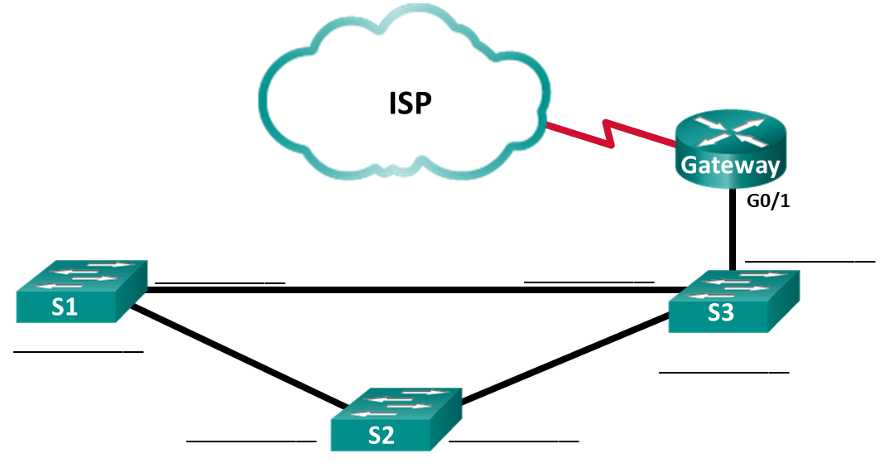

**F0/24**

**G0/2**

**F0/24**

**G0/1**

**G0/2**

**F0/24**

**G0/1**

1. Reflection



1. Reflection

Within a network, on which interfaces should you not use discovery protocols? Explain.

_______________________________________________________________________________________

_______________________________________________________________________________________

_______________________________________________________________________________________

_______________________________________________________________________________________

**Los protocolos de descubrimiento no deben usarse en interfaces que se enfrentan a redes externas porque estos protocolos brindan información sobre la red interna. Esta información permite a los atacantes obtener información valiosa sobre la red interna y explotarla.**

Discovery protocols should not be used on interfaces that are facing the external networks because these protocols provide insights about the internal network. This information allows attackers to gain valuable information about the internal network and exploit the network.

1. Router Interface Summary Table

|  |  |  |  |  |
| --- | --- | --- | --- | --- |
| Router Interface Summary | | | | |
| Router Model | Ethernet Interface #1 | Ethernet Interface #2 | Serial Interface #1 | Serial Interface #2 |
| 1800 | Fast Ethernet 0/0 (F0/0) | Fast Ethernet 0/1 (F0/1) | Serial 0/0/0 (S0/0/0) | Serial 0/0/1 (S0/0/1) |
| 1900 | Gigabit Ethernet 0/0 (G0/0) | Gigabit Ethernet 0/1 (G0/1) | Serial 0/0/0 (S0/0/0) | Serial 0/0/1 (S0/0/1) |
| 2801 | Fast Ethernet 0/0 (F0/0) | Fast Ethernet 0/1 (F0/1) | Serial 0/1/0 (S0/1/0) | Serial 0/1/1 (S0/1/1) |
| 2811 | Fast Ethernet 0/0 (F0/0) | Fast Ethernet 0/1 (F0/1) | Serial 0/0/0 (S0/0/0) | Serial 0/0/1 (S0/0/1) |
| 2900 | Gigabit Ethernet 0/0 (G0/0) | Gigabit Ethernet 0/1 (G0/1) | Serial 0/0/0 (S0/0/0) | Serial 0/0/1 (S0/0/1) |
| **Note**: To find out how the router is configured, look at the interfaces to identify the type of router and how many interfaces the router has. There is no way to effectively list all the combinations of configurations for each router class. This table includes identifiers for the possible combinations of Ethernet and Serial interfaces in the device. The table does not include any other type of interface, even though a specific router may contain one. An example of this might be an ISDN BRI interface. The string in parenthesis is the legal abbreviation that can be used in Cisco IOS commands to represent the interface. | | | | |

1. Device Configs - Final
2. Router ISP

ISP# **show run**

Building configuration...

Current configuration : 1285 bytes

!

version 15.4

service timestamps debug datetime msec

service timestamps log datetime msec

no service password-encryption

!

hostname ISP

!

boot-start-marker

boot-end-marker

!

no aaa new-model

memory-size iomem 15

!

ip cef

no ipv6 cef

!

multilink bundle-name authenticated

!

cts logging verbose

!

redundancy

!

lldp run

!

interface Embedded-Service-Engine0/0

no ip address

shutdown

!

interface GigabitEthernet0/0

no ip address

shutdown

duplex auto

speed auto

!

interface GigabitEthernet0/1

no ip address

shutdown

duplex auto

speed auto

!

interface Serial0/0/0

no ip address

shutdown

!

interface Serial0/0/1

ip address 209.165.200.225 255.255.255.252

clock rate 125000

!

ip forward-protocol nd

!

no ip http server

no ip http secure-server

!

control-plane

!

line con 0

line aux 0

line 2

no activation-character

no exec

transport preferred none

transport output pad telnet rlogin lapb-ta mop udptn v120 ssh

stopbits 1

line vty 0 4

login

transport input none

!

scheduler allocate 20000 1000

!

end

1. Router Gateway

Gateway# **show run**

Building configuration...

Current configuration : 1524 bytes

!

version 15.4

service timestamps debug datetime msec

service timestamps log datetime msec

no service password-encryption

!

hostname Gateway

!

boot-start-marker

boot-end-marker

!

no aaa new-model

memory-size iomem 15

!

no ip domain lookup

ip cef

no ipv6 cef

!

multilink bundle-name authenticated

!

cts logging verbose

!

redundancy

!

lldp run

!

interface Embedded-Service-Engine0/0

no ip address

shutdown

!

interface GigabitEthernet0/0

no ip address

shutdown

duplex auto

speed auto

!

interface GigabitEthernet0/1

ip address 192.168.1.254 255.255.255.0

ip nat inside

ip virtual-reassembly in

duplex auto

speed auto

!

interface Serial0/0/0

no ip address

shutdown

clock rate 125000

!

interface Serial0/0/1

ip address 209.165.200.226 255.255.255.252

ip nat outside

ip virtual-reassembly in

no cdp enable

!

ip forward-protocol nd

!

no ip http server

no ip http secure-server

!

ip nat inside source list 1 interface Serial0/0/1 overload

!

access-list 1 permit 192.168.1.0 0.0.0.255

!

control-plane

!

line con 0

line aux 0

line 2

no activation-character

no exec

transport preferred none

transport output pad telnet rlogin lapb-ta mop udptn v120 ssh

stopbits 1

line vty 0 4

login

transport input none

!

scheduler allocate 20000 1000

!

end

1. Switch S1

S1# **show run**

Building configuration...

Current configuration : 1308 bytes

!

version 15.0

no service pad

service timestamps debug datetime msec

service timestamps log datetime msec

no service password-encryption

!

hostname S1

!

boot-start-marker

boot-end-marker

!

no aaa new-model

system mtu routing 1500

!

spanning-tree mode pvst

spanning-tree extend system-id

!

vlan internal allocation policy ascending

lldp run

!

interface FastEthernet0/1

!

interface FastEthernet0/2

!

interface FastEthernet0/3

!

interface FastEthernet0/4

!

interface FastEthernet0/5

!

interface FastEthernet0/6

!

interface FastEthernet0/7

!

interface FastEthernet0/8

!

interface FastEthernet0/9

!

interface FastEthernet0/10

!

interface FastEthernet0/11

!

interface FastEthernet0/12

!

interface FastEthernet0/13

!

interface FastEthernet0/14

!

interface FastEthernet0/15

!

interface FastEthernet0/16

!

interface FastEthernet0/17

!

interface FastEthernet0/18

!

interface FastEthernet0/19

!

interface FastEthernet0/20

!

interface FastEthernet0/21

!

interface FastEthernet0/22

!

interface FastEthernet0/23

!

interface FastEthernet0/24

!

interface GigabitEthernet0/1

!

interface GigabitEthernet0/2

!

interface Vlan1

no ip address

!

ip http server

ip http secure-server

!

line con 0

line vty 5 15

!

end

1. Switch S2

S2# **show run**

Building configuration...

Current configuration : 1308 bytes

!

version 15.0

no service pad

service timestamps debug datetime msec

service timestamps log datetime msec

no service password-encryption

!

hostname S2

!

boot-start-marker

boot-end-marker

!

no aaa new-model

system mtu routing 1500

!

spanning-tree mode pvst

spanning-tree extend system-id

!

vlan internal allocation policy ascending

lldp run

!

interface FastEthernet0/1

!

interface FastEthernet0/2

!

interface FastEthernet0/3

!

interface FastEthernet0/4

!

interface FastEthernet0/5

!

interface FastEthernet0/6

!

interface FastEthernet0/7

!

interface FastEthernet0/8

!

interface FastEthernet0/9

!

interface FastEthernet0/10

!

interface FastEthernet0/11

!

interface FastEthernet0/12

!

interface FastEthernet0/13

!

interface FastEthernet0/14

!

interface FastEthernet0/15

!

interface FastEthernet0/16

!

interface FastEthernet0/17

!

interface FastEthernet0/18

!

interface FastEthernet0/19

!

interface FastEthernet0/20

!

interface FastEthernet0/21

!

interface FastEthernet0/22

!

interface FastEthernet0/23

!

interface FastEthernet0/24

!

interface GigabitEthernet0/1

!

interface GigabitEthernet0/2

!

interface Vlan1

no ip address

!

ip http server

ip http secure-server

!

line con 0

line vty 5 15

!

end

1. Switch S3

S3# **show run**

Building configuration...

Current configuration : 1364 bytes

!

version 15.0

no service pad

service timestamps debug datetime msec

service timestamps log datetime msec

no service password-encryption

!

hostname S3

!

boot-start-marker

boot-end-marker

!

no aaa new-model

system mtu routing 1500

!

spanning-tree mode pvst

spanning-tree extend system-id

!

vlan internal allocation policy ascending

lldp run

!

interface FastEthernet0/1

!

interface FastEthernet0/2

!

interface FastEthernet0/3

!

interface FastEthernet0/4

!

interface FastEthernet0/5

!

interface FastEthernet0/6

!

interface FastEthernet0/7

!

interface FastEthernet0/8

!

interface FastEthernet0/9

!

interface FastEthernet0/10

!

interface FastEthernet0/11

!

interface FastEthernet0/12

!

interface FastEthernet0/13

!

interface FastEthernet0/14

!

interface FastEthernet0/15

!

interface FastEthernet0/16

!

interface FastEthernet0/17

!

interface FastEthernet0/18

!

interface FastEthernet0/19

!

interface FastEthernet0/20

!

interface FastEthernet0/21

!

interface FastEthernet0/22

!

interface FastEthernet0/23

!

interface FastEthernet0/24

!

interface GigabitEthernet0/1

!

interface GigabitEthernet0/2

!

interface Vlan1

no ip address

!

ip http server

ip http secure-server

!

line con 0

line vty 5 15

!

end